Lab Report
Use this template to document your work as you complete your assignment.

Your Information
Your Name: Damien Harmon
Assignment Title: Project 4.2 Advanced Modeling and Optimization

Screenshots
As you complete the procedure, add the screenshots for the required step(s) below. Be sure to include your computer system date and time.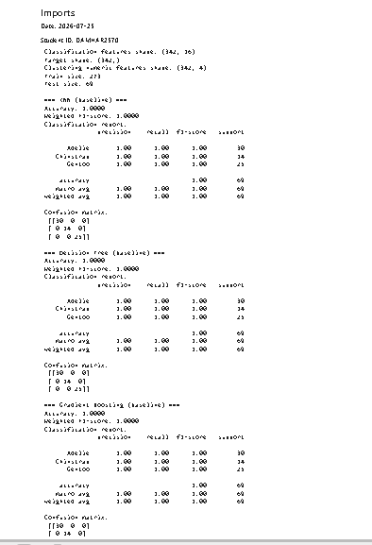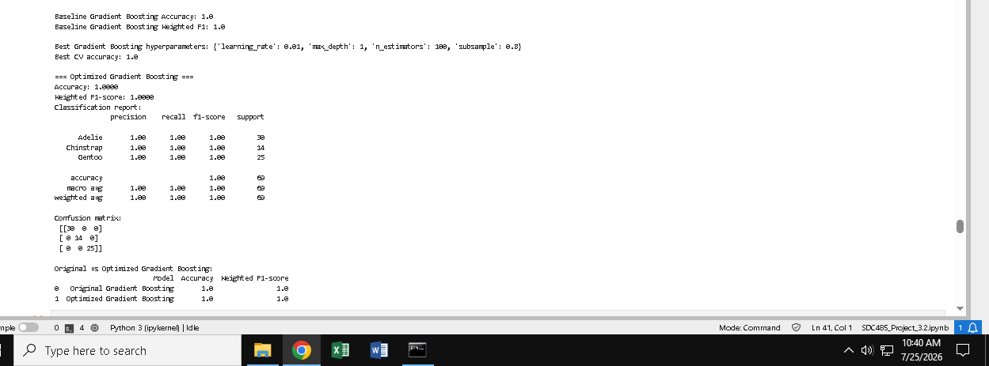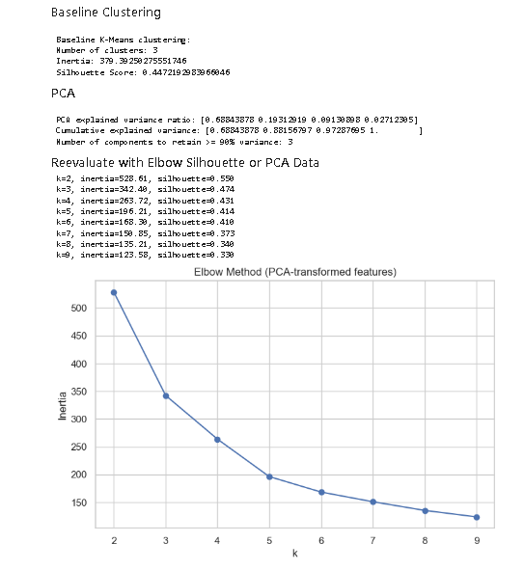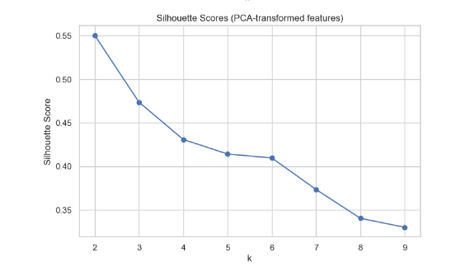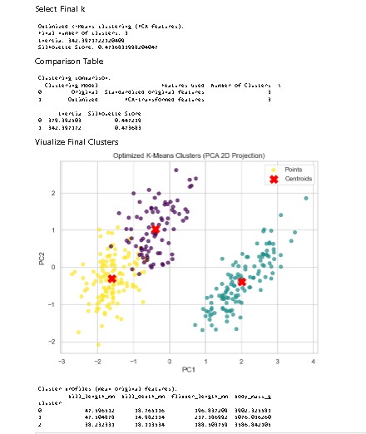

Questions
Answer the required questions in the space below.
Why you chose the classification model (e.g., Gradient Boosting).
Baseline vs optimized performance (accuracy, weighted F1, confusion matrix).
Overfitting control technique and how it helps.
Elbow vs Silhouette suggested k and any disagreement.
Final k choice and justification.
Cluster characteristics based on mean original features.
Limitations (sample size, feature choice, species imbalance, etc.).

